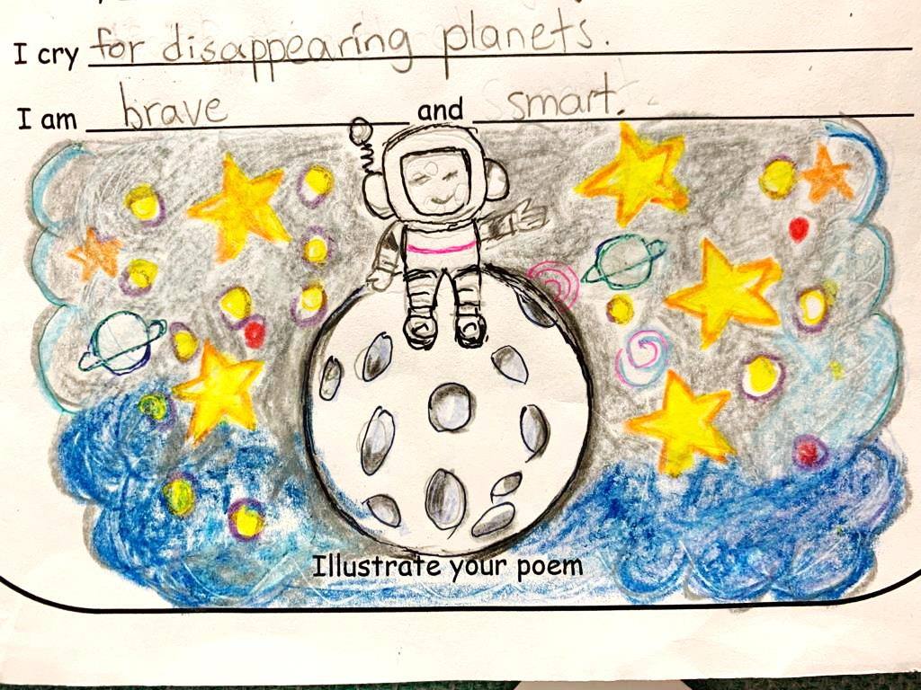A Poem

**I am…**

I am brave and smart.

I wonder if I could be an astronaut.

I hear the sounds from outer space.

I see our beautiful blue planet.

I want to build cities on the Moon.

I am brave and smart.

I pretend to live on the Moon.

I go to everywhere on the Moon.

I touch the moonrocks.

I worry about if the air is enough or not.

I cry for disappearing planets.

I am brave and smart.

By Louis Zhou

J. 2 Hope